User Testing Summary Report
1. Introduction
To assess the usability, user acceptance, and functional value of the ChiForest unmanned vending machine App, we conducted a round of user testing with a representative group of participants. The survey examined usage frequency, willingness to adopt the app, perceived improvements compared to existing shopping applications, and users’ impressions of the key features.
This report summarizes the findings based on the collected quantitative data.

2. Expected Usage Frequency
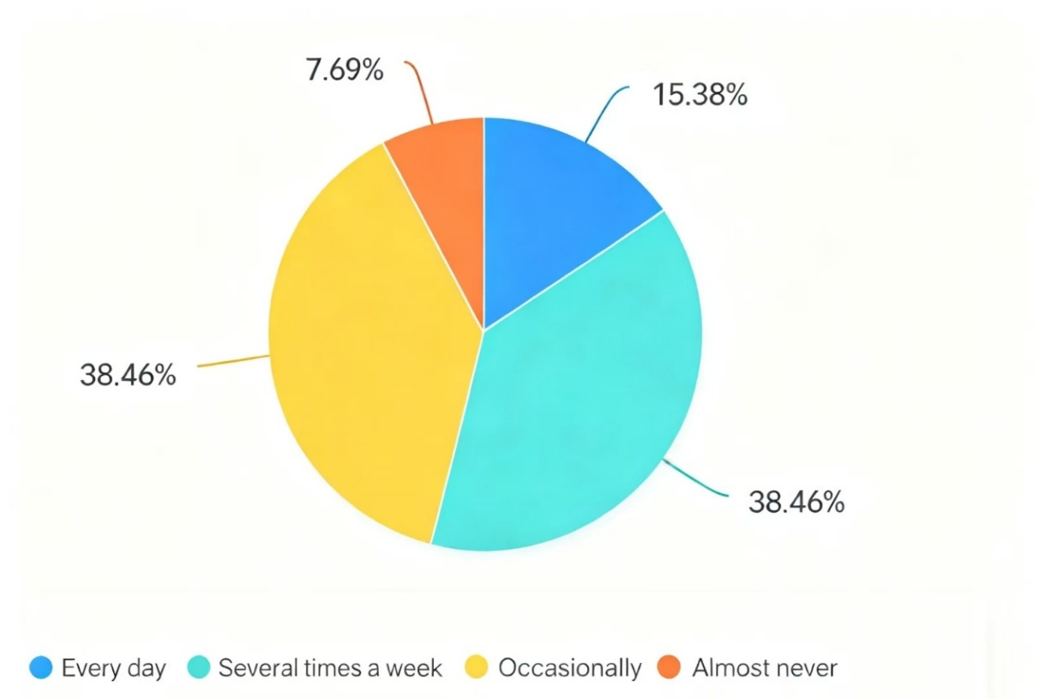
The first chart shows how often participants expect they would use the app:
- 38.46% — Several times a week
- 38.46% — Occasionally
- 15.38% — Every day
- 7.69% — Almost never
Interpretation:
Nearly 92% of users anticipate using the app at least occasionally. This strong potential usage reflects a clear need for real-time vending machine information, especially in environments such as campuses, office buildings, and public areas. Daily and weekly usage expectations further indicate strong practical value.

3. Willingness to Use the App
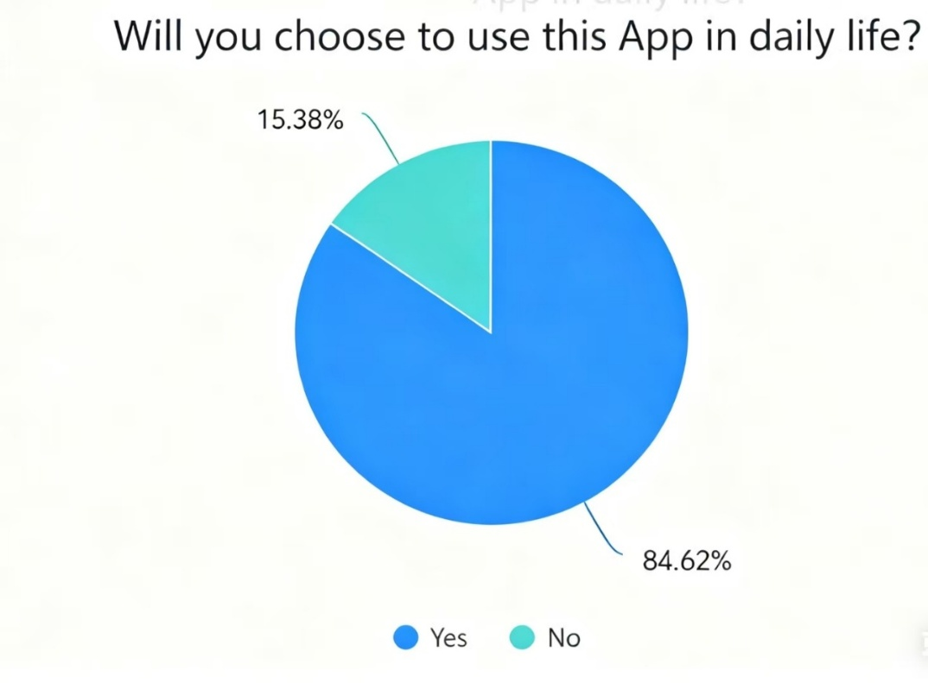
The second chart demonstrates user intention toward real-life adoption:
- 84.62% — Yes, they would use the app
- 15.38% — No
Interpretation:
A large majority of participants expressed willingness to use the ChiForest app. This suggests that the core concept—allowing users to check product availability and locate machines in real time—is appealing and aligns with user needs.

4. Perceived Improvement Over Existing Shopping Apps
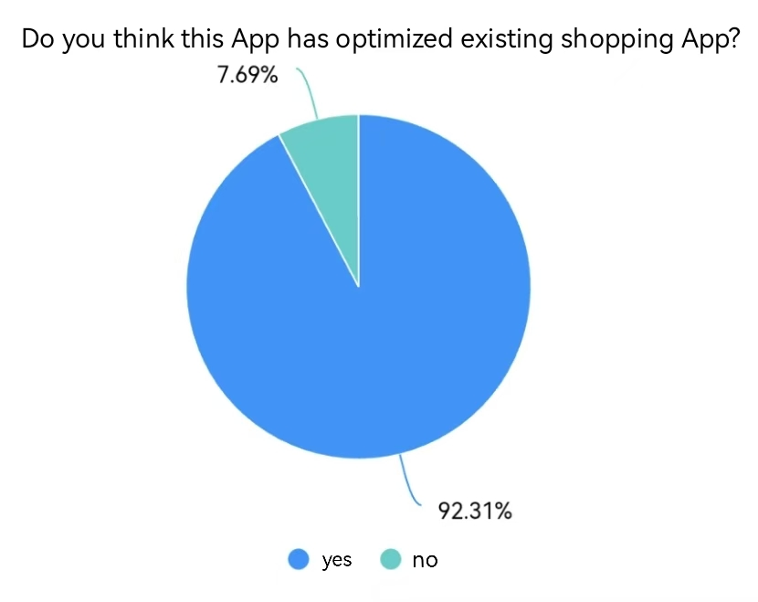
Participants were asked whether they believe this app improves upon existing shopping app experiences:
- 92.31% — Yes
- 7.69% — No
Interpretation:
Most respondents believe the app offers meaningful improvements. Users noted that traditional shopping apps do not provide vending-machine–specific features such as machine locations or real-time product status. This indicates that the ChiForest app effectively fills a practical gap in current digital shopping tools.

5. Feature Evaluation
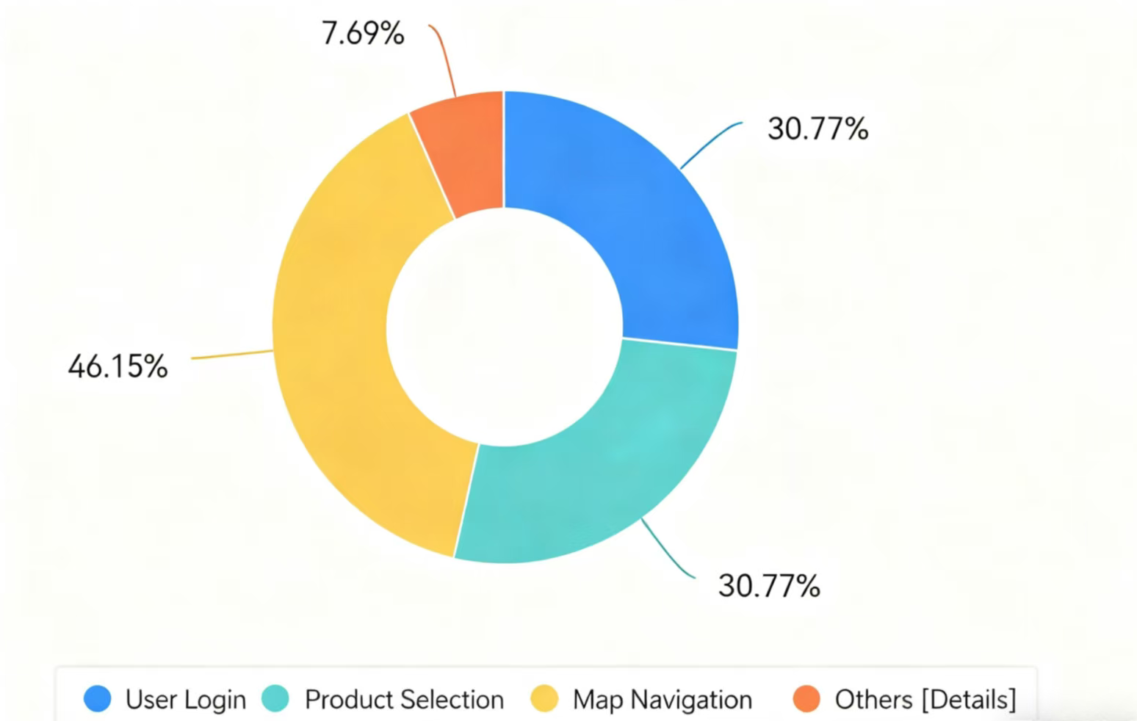
The final chart highlights which features users considered the most valuable:
- 46.15% — Map Navigation
- 30.77% — Product Selection
- 30.77% — User Login
- 7.69% — Others (UI details, additional pages)
Interpretation:
- Map Navigation is the standout feature, valued for helping users locate machines quickly and conveniently.
- Product Selection and User Login received positive feedback for clarity and ease of use.
- The small percentage under “Others” refers mainly to UI styling details and suggestions for interface refinement.

6. Key Insights
Based on the survey data, several important insights emerged:
(1) Strong User Acceptance
More than 84% of users are willing to use the app, indicating strong potential for widespread adoption.
(2) Recognized Practical Value
With 92% believing the app enhances existing shopping experiences, the concept is validated as meaningful and necessary.
(3) Navigation as the Core Feature
Navigation plays a central role in usability. Users value accurate vending machine locations and easy map access. Future improvements may include:
- Real-time stock levels
- Estimated walking distance
- Route optimization
(4) Opportunities for UI Refinement
While feedback was largely positive, users suggested enhancements such as:
- More consistent color themes
- Improved spacing and alignment
- Smoother page transitions

7. Conclusion
The results of the user testing demonstrate a highly positive overall response. Users acknowledged the app’s strengths, particularly in providing real-time information and convenient machine navigation—features that are not commonly found in existing shopping apps. The data indicates strong usage potential and clear user demand.
Moving forward, refinements in visual design, navigation enhancements, and expanded real-time data features could further elevate the user experience. Overall, the ChiForest unmanned vending machine App shows strong promise as a practical and user-friendly solution for everyday micro-purchases.

